**Homogenic Vehicle Schedule**

***Work-flow to Use Homogenic Vehicle Schedule***

Use **Add Preference** to obtain a baseline dialog that sets a Homogenic Vehicle Sched- ule for a single criterion only



Repeat **Add Preference** for additional instances of the baseline dialog



Use **Load Template** modify the preference for a wide variety of conditions



Repeat **Load Template** for additional instances of any template



***Preference Overview***

There may be economic advantages in keeping each vehicle on one route, or geo- graphically close routes. The Homogenic baseline preference provides these basic cri- teria. The Homogenic templates add advanced additional filtering to the basic criteria.

***Add Preference Dialog***

**Purpose:**

The baseline dialog provides the simplest form of homogeneity by any one of the cri- teria, Sign, Route, Region and Route Group.

**Prerequisites:**

To apply Regions, they must be defined as user data in your initial Schedule.



You should have already defined your route groups. See Miscellaneous Preferences,



**Route Groups**.

**Opening Dialog:**

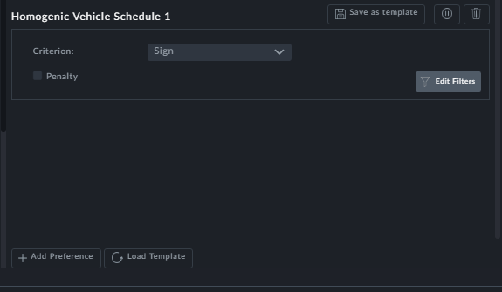

*Figure 1-1: Homogenic Vehicle Schedule - Basic dialog*

**Points to note:**

The **Criterion** field opens a pick list:

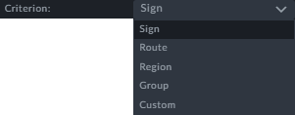

*Figure 1-2: Criterion selection*

This preference may be strict or flexible by assigning a penalty



Using **Edit Filters** you can restrict the Homogenic Vehicle Schedule to a time interval



Using **Edit Filters** you can restrict it to one or more vehicle types



Use **Add Preference** to create additional instances with different Homogenic Vehicle



Schedules

**Criterion**: The **Custom** item is similar to Expert Mode, primarily intended for use by



Optibus Professional Services to create custom made criterion.

**Example 1.**

***Scenario:***

We will create homogeneous routes by Sign for Urban vehicles. Here is a segment of the Vehicle Gantt filtered for Urban vehicles. (The schedule used here has undergone first optimization for Vehicles and Drivers.)

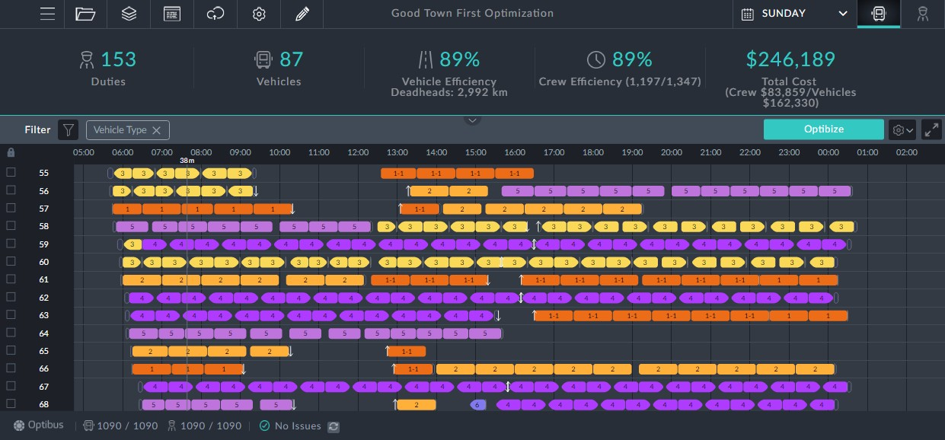

In the preference, choose Sign and then choose Urban vehicles in Edit Filter. Save and

optimize.

***Outcome:***

First, here is the corresponding segment of the Vehicle Gantt:

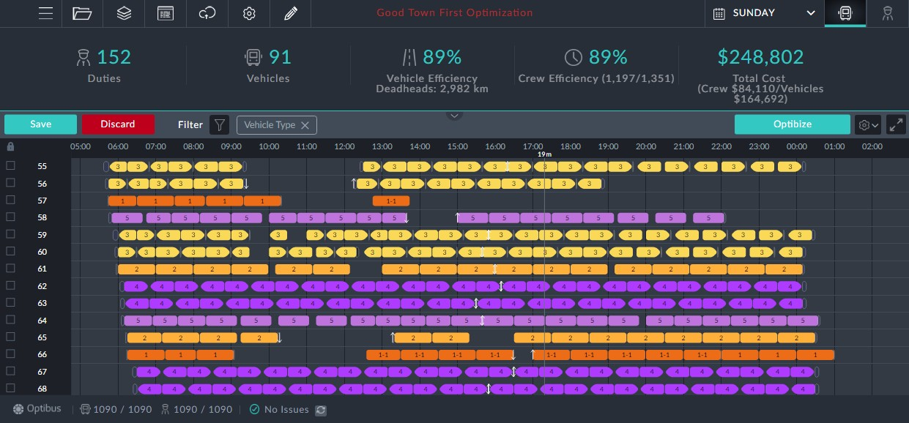

The effect on the Gantt is very noticeable: All of the Urban trips are Signs homogeneous. In the KPIs, the number of vehicles has risen significantly by 4, also reflected in the

increased Total Cost.

**Example 2.**

***Scenario:***

Same as Example 1 but set a penalty of 20.

***Outcome:***

First, here is the corresponding segment of the Vehicle Gantt:

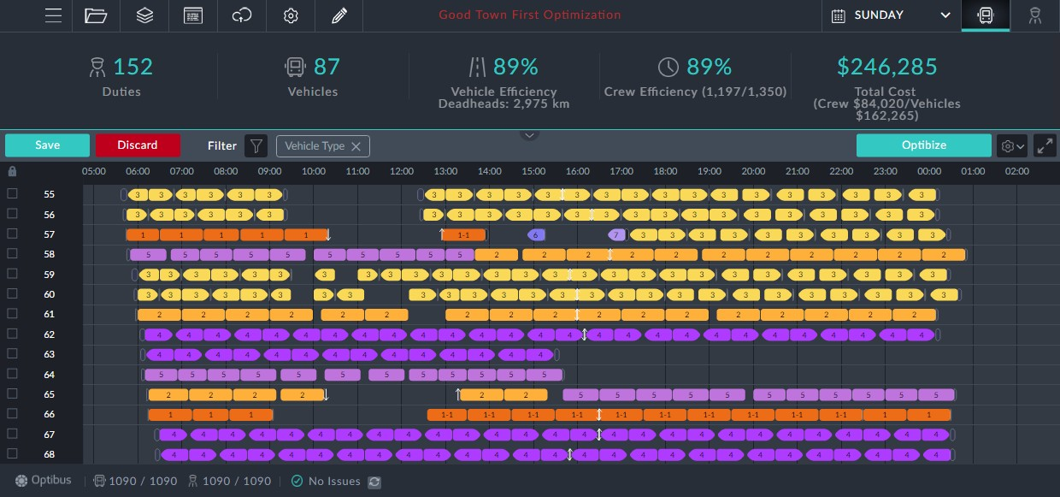

The effect on the Gantt is still very noticeable, but not all of the Urban trips are Signs homogeneous.

In the KPIs, the number of vehicles has not changed. The Total Cost has increased by a small amount.

This suggests that there is no real loss in making the schedule sign homogeneous. It also suggests that our penalty may be too low to make a difference. If we set the penalty to

50, there is some further relaxation of sign homogeneity. There is a very small increase in Total Cost.

***Templates Available from Optibus***

*Table 1-1: Templates Summary*

|  |  |  |
| --- | --- | --- |
| **Template Name** | **Purpose** | **Reference** |
| Override min- imum trip duration | This preference extends the minimum trip duration to the time specified for a single route or the whole schedule. It does not change the trip duration as shown in the vehicle information boxes. It simply adds time to the end of the trips delaying the trip following. | **Override trip min- imum trip duration** |
| Duration dependent recovery | This preference extends the minimum trip duration by a fixed "layover" percentage for a single route or the whole schedule. It does not change the trip duration as shown in the vehicle information boxes. It simply adds time to the end of trips delaying the trip following. | **Duration dependent recovery** |

|  |  |  |
| --- | --- | --- |
| **Template Name** | **Purpose** | **Reference** |
| Duration dependent recovery - By route group | This preference extends the minimum trip duration by a fixed percentage for a route group. It does not change the trip duration as shown in the vehicle information boxes. It simply adds time to the end of trips delaying the trip fol- lowing. | **Duration dependent recovery - By route group** |
| Prefer inbound\out- bound scheduling - By route sign | This provides for homogeneity where trips followed by their reverse trips. | **Prefer inbound\out- bound scheduling - By route sign** |
| Route group schedul- ing | Apply homogeneity to a specific route group. | **Route group schedul- ing** |
| Prefer interline between routes | This preference is the opposite of homogeneity by any one of the criteria, Sign, Route, Region and Route Group. | **Prefer interline between routes** |
| Single route schedul- ing | This preference applies homogeneity for a single sign (or a list of signs) | **Single route schedul- ing** |
| Prefer geographic round trip | This preference sets outbound and inbound trips together with the following relaxation: A trip will still be considered to be "inbound" for this purpose if its destination is within a given distance of the actual start location. A simple example of this is a vehicle leaving from Platform 1 of a large shopping center, but returning to Platform 20, 500 meters from its start location. | **Prefer geographic round trip** |
| Adjust deadheads to regulation | This preference is used in order to primarily create the vehicles in a way that is costumed to the driver break regulations. high as reflected by the default value. | **Adjust deadheads to regulation** |
| Keep vehicle in area | This preference is similar to Deadhead Limitations: Minimize Vehicle Cruise Preference. It is used to minimize deadhead Km by preventing the vehicles from preforming trips that are getting too far away from the depot. This is done by specifying a deadhead distance factor. | **Keep vehicle in area** | |
| Adjust depot pull in/out to regulation | This preference is similar to Adjust deadheads to reg- ulation. Recall that Pull in and Pull out are special dead- heads. | **Adjust depot pull in/out to regulation** |

***A General Note About Homogenic Templates***

The templates share a common "heading" section that looks like this:

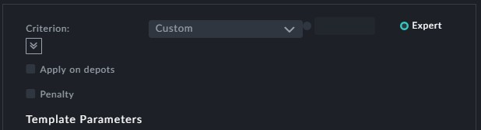

You should ignore the **Custom** and the **Apply on depots** fields.



The **Penalty** field will sometimes be set with a default value. Consider leaving it as is. The baseline dialog and templates are cumulative conditions



This preference extends the minimum trip duration to the time specified for a single route or the whole schedule. It does not change the trip duration as shown in the vehicle information boxes. It simply adds time to the end of trips delaying the trip following.

**Prerequisites:** None.

**Opening Dialog:**

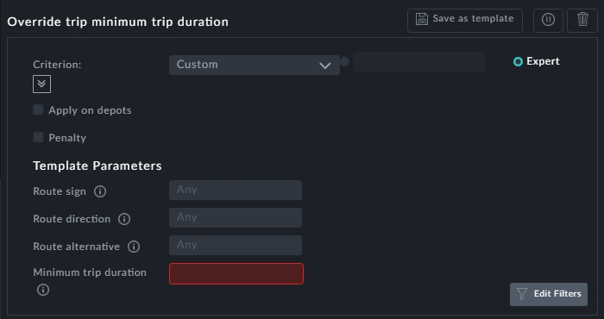

**Points to note:**

**Minimum trip duration**: This field is mandatory, in minutes.



This preference defaults to all routes. You may select several routes by using addi- tional instances of this template



This preference may be strict or may be made flexible by assigning a penalty



This preference extends the minimum trip duration by a fixed "layover" percentage for a single route or the whole schedule. It does not change the trip duration as shown in the vehicle information boxes. It simply adds time to the end of trips delaying the trip fol- lowing.

**Prerequisites:** None.

**Opening Dialog:**

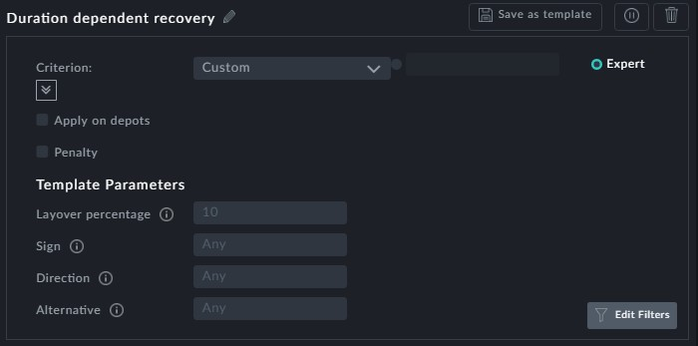

**Points to note:**

**Layover percentage**: Note the default value.



This preference defaults to all routes. You may select several routes by using addi- tional instances of this template



To use several routes, place them in a Route Group (see **Route Groups**)

and then use Duration dependant recovery - By route group

This preference may be strict or may be made flexible by assigning a penalty



This preference extends the minimum trip duration by a fixed percentage for a route group. It does not change the trip duration as shown in the vehicle information boxes. It simply adds time to the end of trips delaying the trip following.

**Prerequisites:**

You should have already defined your route groups. See Miscellaneous Preferences,

**Route Groups**.

**Opening Dialog:**

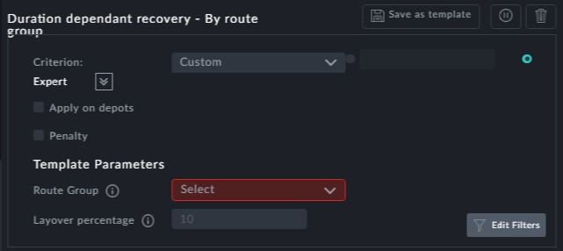

**Points to note:**

**Route Group**: This field is mandatory



**Layover percentage**: Note the default value.



This preference may be strict or may be made flexible by assigning a penalty



This provides for homogeneity where trips are followed by their reverse trips.

**Prerequisites:** None.

**Opening Dialog:**

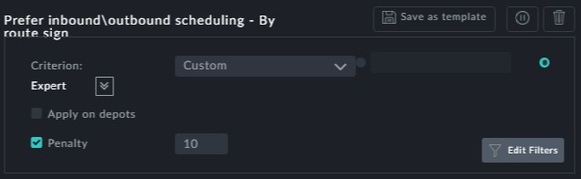

**Points to note:**

This preference sets a default penalty



The only variations possible are through **Edit Filters**



Apply homogeneity to a specific route group.

**Prerequisites:**

You should have already defined your route groups. See Miscellaneous Preferences,

**Route Groups**.

**Opening Dialog:**

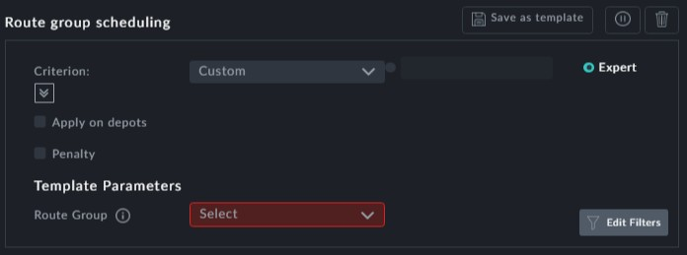

**Points to note:**

**Route Group**: This is a mandatory field



This preference may be strict or may be made flexible by assigning a penalty



This preference is the opposite of homogeneity by any one of the criteria, Sign, Route, Region and Route Group.

**Prerequisites:** None.

**Opening Dialog:**

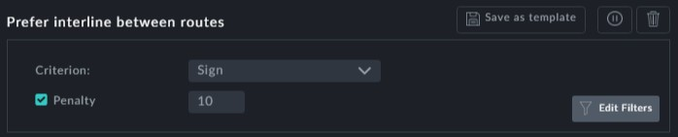

**Points to note:**

**Criterion**: The **Criterion** field opens a pick list:



This preference sets a default penalty



This preference applies homogeneity for a single sign (or a list of signs).

**Prerequisites:** None.

**Opening Dialog:**

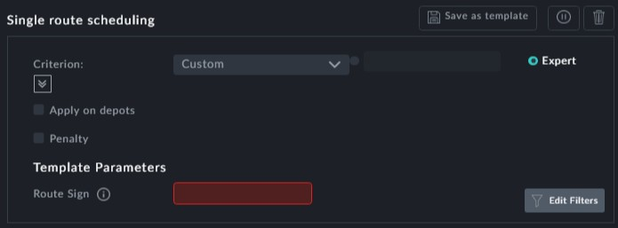

**Points to note:**

**Route Sign**: This filed is mandatory



This preference may be strict or may be made flexible by assigning a penalty



This preference sets outbound and inbound trips together with the following relaxation: A trip will still be considered to be "inbound" for this purpose if its destination is within a given distance of the actual start location. A simple example of this is a vehicle leaving from Platform 1 of a large shopping center, but returning to Platform 20, 500 meters from its start location.

**Prerequisites:** Geographic data (GPS coordinates) for start-trip and end-trip locations must be stored in the schedule Dataset.

**Opening Dialog:**

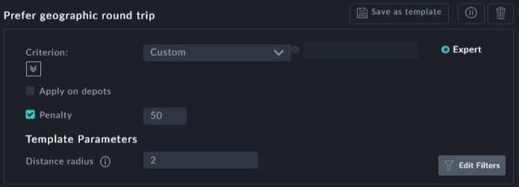

**Points to note:**

**Penalty**: The Penalty field is set to a default value.



**Distance radius**: This is the maximum distance within which we consider the trip start location and trip end locations to be "the same". In our example above, the actual distance was 0.5 km, considerably less than the 2km default shown.



This field is in Km (or miles, depending on your location) and is set to a default value.

This preference is used in order to primarily create the vehicles in a way that is costumed to the driver break regulations. **Prerequisites:** None.

**Opening Dialog:**

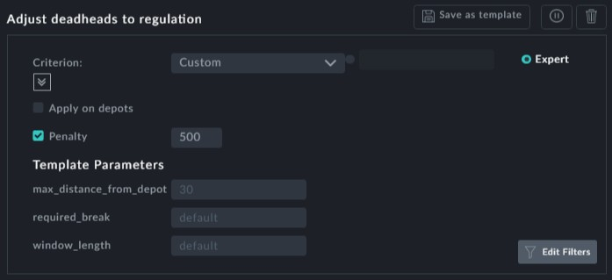

*Figure 1-3: Adjusting deadheads to regulation*

**Points to note:**

**Max distance from depot**: This is the max distance that will be allowed for a deadhead back to the depot.



**Required break**: This defaults to the **Break length** in Drivers: **Work Limitations**. You may make it longer.



**Window length**: A sliding interval during which there must be at least one break. This defaults to the **Required every** in Drivers: Leave it at default.



This preference may be strict or may be made flexible by assigning a penalty. It is best left as flexible with a high penalty as shown.



This preference is similar to Deadheads Limitation**Minimize Vehicle CruisePreference**. It is used to minimized deadhead Km by preventing the vehicles from preforming trips that are getting too far away from the depot. This is done by specifying a deadhead distance factor.

**Prerequisites:** None.

**Opening Dialog:**

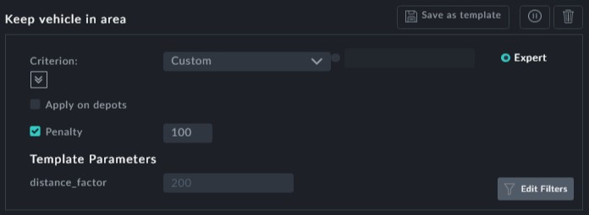

**Points to note:**

**Distance factor**: The distance from the vehicle's "home" depot should be real- istically large enough, but the penalty for violation should also be realistically large.



This preference may be strict or may be made flexible by assigning a penalty as shown



This preference is similar to **Adjust deadheads to regulation**. Recall that Pull in and

Pull out are special deadheads.

**Prerequisites:** None.

**Opening Dialog:**

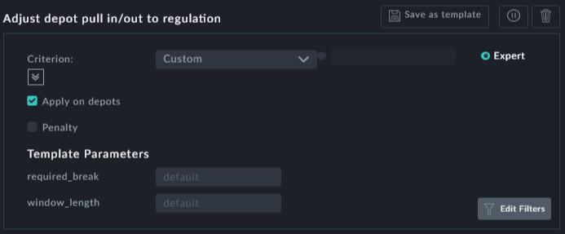

**Points to note:**

**Required break**: This defaults to the **Break length** in Drivers: **Work Limitations**. You may make it longer.



**Window length**: A sliding interval during which there must be at least one break. This defaults to the **Required every** in Drivers: Work Lmitations. Leave it at default.This preference may be strict or may be made flexible by assigning a penalty

